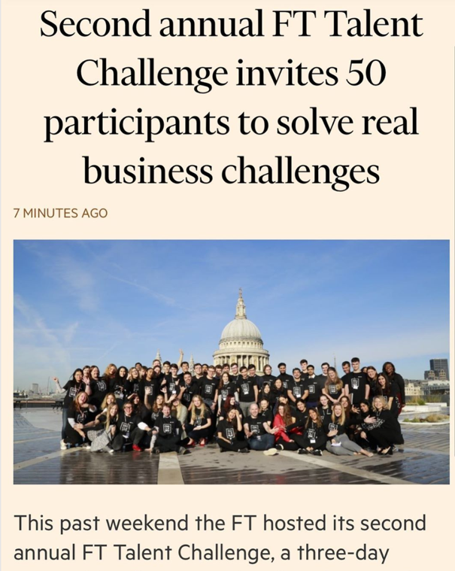

**FT Talent Challenge Experience**

**26-28th October 2019 London, Financial Times HQ**

How does a 131-year-old newspaper with one million paying subscribers branch out from its traditional customer base: university-educated, upper-middle class, forty-something years old, white, British, businessmen, working in the financial districts of London?

From the 25th to 28th October 2019, I travelled to the U.K. to participate in the Financial Times’ second annual Talent Challenge. The aim was to brainstorm among fifty ‘challengers’ and to present our ideas to a panel of judges composed of the FT’s Executive Board.

My first challenge involved getting out of Beijing. My outbound Air France flight unexpectedly turned back to Beijing after two hours mid-air and made an emergency landing. Staff later told us that a fuel leak posed an engine fire risk. With no further instructions, I scrambled together a replacement flight to London via Tokyo and arrived half a day later than planned but just in time for the start of the Challenge.

Upon arrival, the event’s casual dress and colloquial speech overturned my earlier impressions of the company. Founded in 1888 and considered the UK’s newspaper of record, I thought that the FT headquarters would embody the stereotypical ‘stiff upper lip’ that whispers ‘keep calm and carry on’ as writers type away the most recent headlines. To the contrary, the organizers, diverse and all-but-one female, rejected the cold, suited and serious picture associated with the favoured business read of financial decision-makers[1].

Over the next three days, I joined forty-eight individuals - Danish twins with a video news start-up, a Lebanese civil rights activist, young black BBC presenters, Silicon Valley data scientists and a Ukrainian drone company founder – to debate and discuss how the FT could adapt to the changing media landscape.

Besides getting to know the Financial Times as a company and how visual journalism is becoming a marked focus, a key takeaway was understanding how embracing change that might affect its image of ‘authority, integrity and accuracy’ is something which the FT takes seriously.

My team’s Big Tech challenge asked us to consider how the FT can compete or collaborate in a world that is dominated by technology companies. Given the FT’s objective of reaching women, youth and audiences beyond the UK, we concluded that the FT’s reputation for quality-reporting and its recent acquisition of a film studio could make it a perfect fit for video streaming services such as Netflix. The organizers welcomed our suggestion as way to signal the FT’s launch into longer-format documentaries investigating business stories through the moving image. Later, in the Q&A, the panellists focused our attention on how a video streaming partnership could affect the FT’s brand and the value in its reputation.

This experience has been worthwhile, and I have learned more than I could have anticipated about the FT, the challenges of news media and the value of reputation to a historic news business.

I would like to thank the Financial Times Talent Team and my professors at Tsinghua University for the opportunity to participate in this event.

Joël N. E. Christoph

Thursday, 21 November, 2019

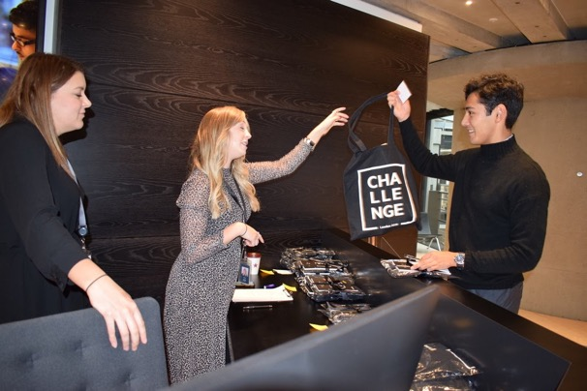

Arriving at the venue. Bracken House is named after Brendan Bracken, the Irish-born Minister of Information in Churchill's 1941-1945 War Cabinet and the founder of the modern version of the Financial Times.

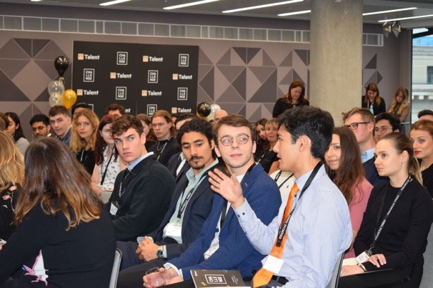

Getting to know the FT – How the Financial Times is tackling the dual challenges of digitalization and globalization as a UK-based paper founded in 1888.

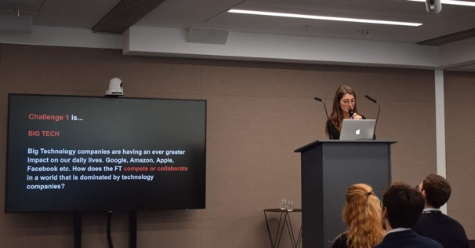

Our team’s challenge - Big Tech: Big Technologies companies are having an ever greater impact on our daily lives. Google, Amazon, Apple, Facebook etc. How does the FT compete or collaborate in a world that is dominated by technology companies?

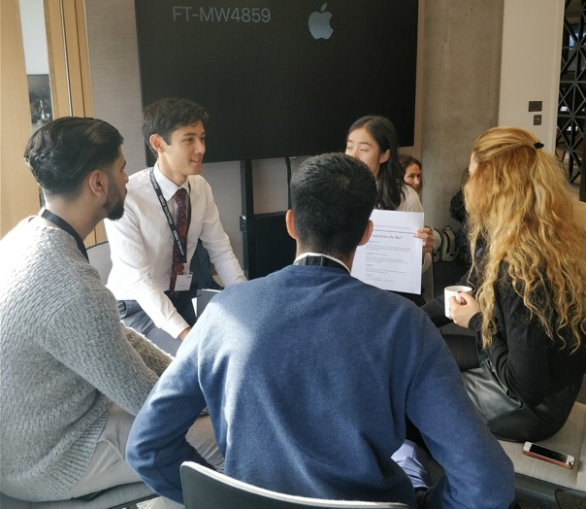

Getting to know my team: Aaron from Birmingham, Haris from London, Lynette from San Francisco and Vittoria from Rome.

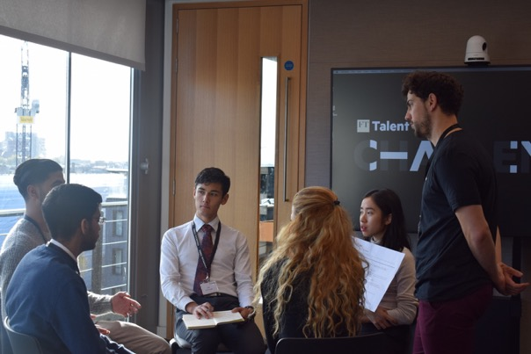

Team brainstorming.

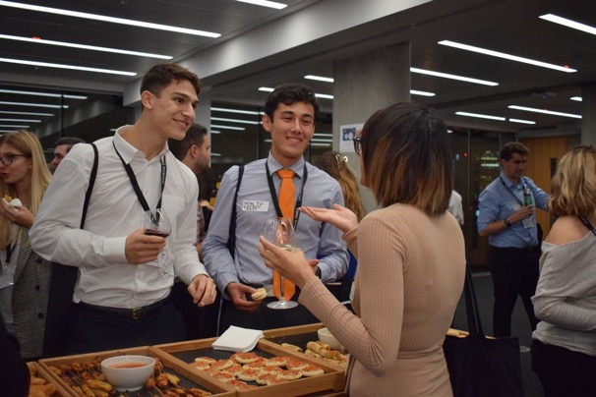

At the evening reception.



The Future of News Workshop with Alan Smith, Head of Visual and Data Journalism at the Financial Times.



Working on the presentation – How the Financial Times as a content producer can partner with video streaming services such as Netflix to reach younger and international audiences beyond the U.K.

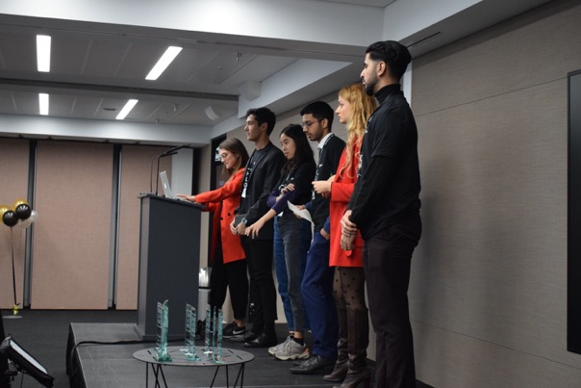

Presenting to the judges.



John Slade, FT Chief Operating Officer, announcing the results.

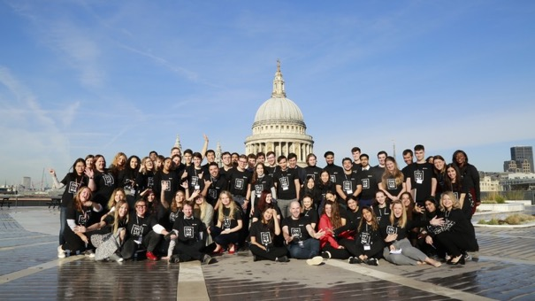

FT Article Link: <https://aboutus.ft.com/en-gb/inside-ft/second-annual-ft-talent-challenge-invites-50-participants-to-solve-real-business-challenges/>

Joel N. E. Christoph 柯卓尔 is a French-Japanese Master’s student in the Tsinghua University-Johns Hopkins University SAIS Global Politics and Economics Dual Degree Program. He is a Young Ambassador at the Carnegie-Tsinghua Center for Global Policy, a COP25 Youth Delegate of the Global Alliance of Universities on Climate and a Digital Civilization Fellow at the Oxford-Hainan Blockchain Research Institute.

1. According to the Global Capital Markets Survey, which measures readership habits amongst most senior financial decision makers in the world's largest financial institutions, the Financial Times is considered the most important business read, reaching 36% of the sample population, 11% more than The Wall Street Journal (WSJ), its main rival.